Effects of Drought and Fertilization on Primary Metabolism in Brassica oleracea (Savoy Cabbage)-A GC-FID/GC-MS Study

Name- Pranjel
Matriculation No.- 44437246
Email address- pranjel200109@gmail.com
Environmental change and chemical communication
Dr Thomas Dussarrat

Contents

- Abstract- 2

- Introduction- 2-4

- Methods- 4-6

- Results- 6-1

- Discussion-11-13

- References- 13-15

Abstract

With the decline over time in climatic conditions, drought will become a very common stress factor for plants. Drought has a negative impact on plants, although plants try to cope to survive by making changes in their metabolic profiles. Meanwhile, human interventions with products like fertilizers are trying to aid plant growth. However, it's not fully clear how these two—natural stress like drought and human help like fertilization—either complement each other or cancel each other out. So, we conducted a study with four different treatments using Savoy cabbage: drought with fertilizer, drought without fertilizer, watered with fertilizer, and watered without fertilizer. We collected leaf samples, then analyzed them for metabolic changes using GC-FID and GC-MS machines. We also prepared PCA, PLS-DA, and ANOVA plots to analyze and interpret the data. Six key metabolites, based on VIP scores, were identified. Our main observations showed that drought elevated the concentration of amino acids like serine and threonine, while fertilization had a positive impact on the concentration of serine and GABA, which is a signaling molecule. Surprisingly, sugars and organic acids did not increase much with fertilization. The only consistent pattern in both conditions was the rise in serine. That suggests its important role in managing both stress and growth. This kind of combined study could be helpful in understanding how natural and human factors can potentially play a vital role in making plants more resilient to climatic stress.

Introduction

The interplay of internal metabolites helps the plants to survive, grow, and adapt. Fundamental metabolites like sugars, amino acids, and organic acids help in carrying out essential processes such as energy production, structural development, and stress response ([Alseekh et al., 2018]; [Scheible et al., 2004]).
As the climatic patterns are becoming more extreme, drought has surfaced as one of the most common and damaging stressors for plants ([Farooq et al., 2009]; [Naseer et al., 2021]). When there is water scarcity,

nutrient uptake from the root decreases, and the stomata close to conserve moisture, leading to a slowdown in the process of photosynthesis. Since energy production and growth have halted, the plants shift into survival mode. In this state, stress-related metabolites—especially certain amino acids—often increase, whereas compounds linked to energy processes decrease ([Urano et al., 2009]; [Obata et al., 2015]).
On the other hand, fertilization, being a human-driven method, helps in enhancing plant growth. It provides additional nutrients like nitrogen, phosphorus, and potassium. They boost metabolic activities like photosynthesis, amino acid synthesis, and water-use efficiency under high-demand conditions ([Hasanuzzaman et al., 2020]; [Chen et al., 2019]). Since they create nutrient-rich conditions, plants consume sugar at a very fast pace, leaving behind very less for storage.
All the previous studies carried out so far have only investigated the impact of either drought or fertilization separately, and not in combination ([Joshi et al., 2010]; [Pires et al., 2016]). So, little is known about their combined effect. It's not very clear whether fertilization can counteract or buffer drought-induced metabolic stress. To address this gap, we tested four treatment groups: non-fertilized water [NW], non-fertilized drought [ND], fertilized water [FW], and fertilized drought [FD].

We selected Brassica oleracea (Savoy cabbage) for our study due to the following reasons:
- Agricultural relevance
- Well-characterized metabolic profile
- Compatibility with GC-FID and GC-MS metabolomics analysis ([Wang et al., 2022])
- It is a commonly consumed food crop, making it a practical choice for studying plant stress responses.

Instead of giving complete focus to phenotypic traits, we focused more on a metabolomics approach to study internal biochemical responses under combined stress–nutrient conditions ([Zhang et al., 2022]). This method helps us to understand plant behavior more deeply than solely focusing on phenotypic observations, as it also takes into consideration all the metabolic cycles and processes.

We hypothesized that:
Drought
- Reduces energy-related metabolites
- Increases stress-associated amino acids
Fertilization
- Might buffer these shifts
- Helps maintain metabolic balance, especially in sugars and amino acids
By tracking changes across all four treatment groups, this study aims to put forward and present future crop management strategies for climate resilience.

Methods

Sampling and Experimental Setup

We took a total of 13 Savoy cabbage (Brassica oleracea) plants for the study, divided equally across four treatment groups: non-fertilized water [NW], non-fertilized drought [ND], fertilized water [FW], and fertilized drought [FD]. We harvested the leaves from each plant and then weighed them immediately. After weighing, we flash-froze them using liquid nitrogen in order to minimize nutrient loss. This step was then followed by manual grinding into fine powder. Apart from this, we also prepared 3–4 blank samples in addition to be used as quality control.

Metabolite Extraction

The extraction of metabolites was done using a biphasic solvent system. A total of 750 µL of a chloroform:methanol:water solution in a ratio of 1:2.5:1 (v/v/v) was added to each sample. The internal standard we used was ribitol at a concentration of 5 mg/100 mL. We then vortexed the

samples manually for 10 seconds, followed by automatic vortexing for another 5 minutes. Following this, 285 µL of deionized water was added, then vortexed again for 15 seconds, and finally centrifuged at 13,000–13,200 rpm for 3 minutes. As a result, it separated into two separate layers. And at last, we transferred 35 µL of the upper aqueous phase into glass microreaction vials.

Drying and Derivatization

We then dried the samples under a gentle nitrogen gas stream to remove all the solvents that got stuck on the leaves. For the process of derivatization, all the steps were performed carefully in glass vials and not plastics in order to avoid chemical interactions. Firstly, methoxyamine hydrochloride (20 mg) was dissolved in 1 mL of pyridine to prepare the methoximation solution. We then added around 100 µL of this solution to each vial and then vortexed, and then vortexing was done for 5 seconds, followed by incubation for 90 minutes at 37°C. In the next step, 100 µL of MSTFA (N-methyl-N-(trimethylsilyl)trifluoroacetamide) was added, vortexed again for 5 seconds, and incubated again for an additional 30 minutes at 37°C to complete the silylation process.

GC-FID and GC-MS Measurement

The metabolite measurements were carried out using two platforms, that is, GC-FID and GC-MS. All processed samples were analyzed on a Shimadzu GC-2010 equipped with a flame ionization detector. For metabolite confirmation, we selected one sample per treatment for GC-MS analysis using a Shimadzu GCMS-QP2020 system. For peak identification, we ran a C7 to C40 alkane series to calculate retention indices. All the samples were measured in dark glass vials with internal inserts to prevent light and material contamination.

Data Processing and Statistical Analysis

The raw chromatographic data that we got from GC-FID and GC-MS

machines were cleaned and grouped using Microsoft Excel and then uploaded to MetaboAnalyst for statistical analysis. We normalized all the values by using Z-score. In MetaboAnalyst, we performed principal component analysis (PCA), partial least squares discriminant analysis (PLS-DA), and ANOVA. In the PLS-DA, we got variable importance in projection (VIP) scores, and we used these VIP scores to identify key metabolites. Six significantly differing metabolites were selected based on VIP threshold and statistical relevance. Finally, we did the metabolite identification by comparing retention indices and GC-MS spectra with JCM spectral libraries and other known standards.

Results

Multivariate Pattern Analysis

PCA

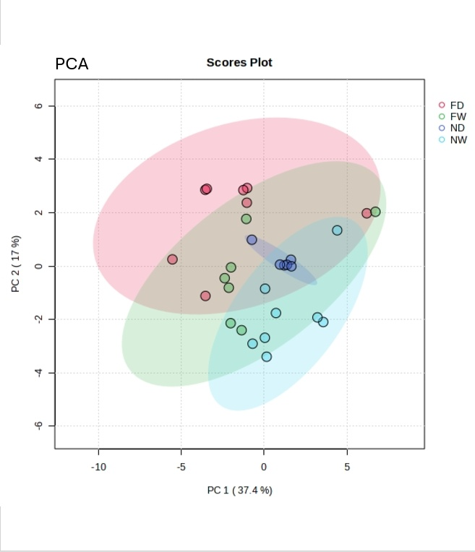
Figure. 1

The PCA (Principal Component Analysis) plot showed that the treatment groups clustered distinctively and very clearly based on their metabolic profiles (Figure 1). The first principal component (PC1) explained 37.4% of the variation, whereas PC2 could explain 32.6% of the variation, together accounting for nearly 70% of the total variance. ND (non-fertilized drought) and FD (fertilized drought) were positioned close to each other, suggesting that drought had a dominant effect on metabolism, regardless of the fertilization. FW (fertilized water) and NW (non-fertilized water) also clustered together, indicating that FW showed more separation from NW, suggesting that fertilization introduced some additional variation even under normal watering.

PLS-DA

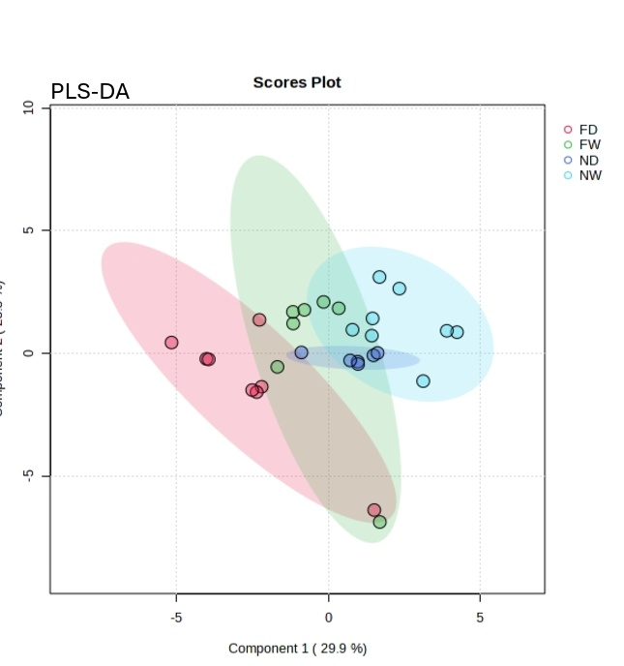
Figure. 2

In the PLS-DA (Partial Least Squares Discriminant Analysis), all four treatments were well-separated based on the key metabolites contributing to the variation (Figure 2). Using the VIP (Variable Importance in Projection) scores, we identified six metabolites that contributed the most to treatment separation: malic acid, citric acid, phosphate_3_1, threonine, serine, and 4-aminobutanoic acid (GABA).

Heatmap

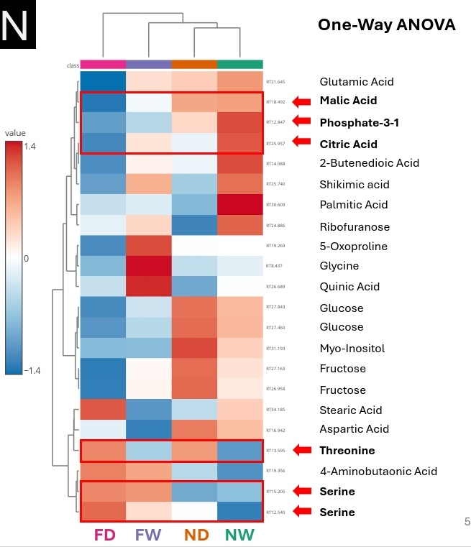
Figure. 3

The heatmap (Figure 3), which was based on hierarchical clustering and ANOVA significance, grouped the samples and metabolites by how abundant they were. ND and FD appeared closer together again, while FW and NW showed clearer metabolic differences. The six selected metabolites showed distinct expression trends across the four treatment groups.

Metabolite-Specific Trends

Drought Effects

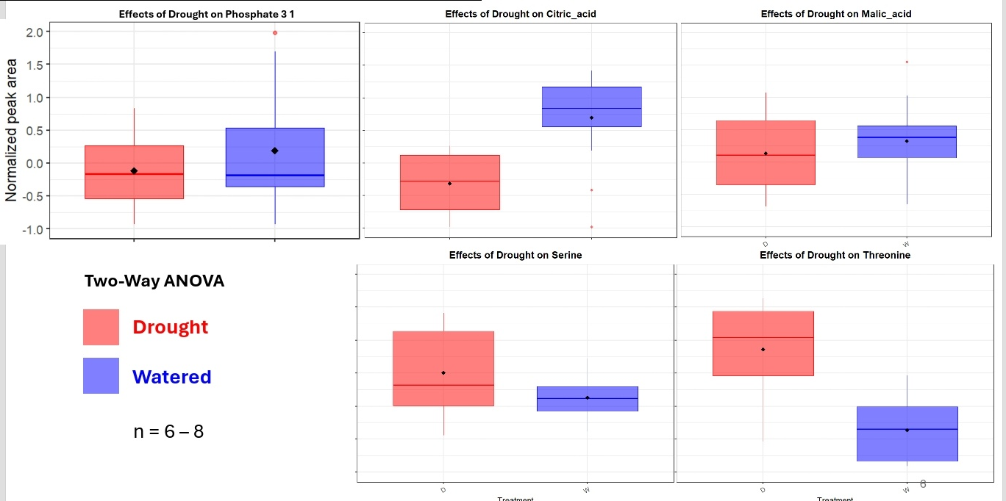
Figure.4 to Figure.8 (From left to right)

Under drought conditions (ND and FD), we observed several clear changes in primary metabolites (Figure.4 to Figure 8). Concentrations of Phosphate_3_1, citric acid and malic acid decreased, indicating a suppression of energy-related pathways. In contrast amino acids such as serine and threonine increased, suggested that drought stress led to formation and accumulation of stress related metabolites. These patterns were more intense in ND than in FD, suggesting that drought strongly affected energy and amino acid metabolism, and that fertilization may have softened the impact slightly.

Fertilization Effects

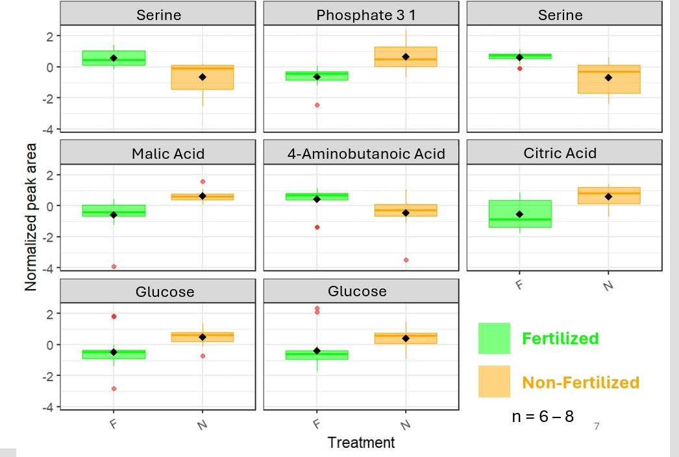
Figure.9 to Figure.16 (From left to right)

Fertilization (FW and FD) also brought noticeable shifts in metabolic levels (Figure 9 to Figure.16). Levels of serine and GABA increased significantly, whereas phosphate_3_1, malic acid, citric acid, and glucose decreased. Interestingly, even though nutrients were added, sugars and organic acids still went down in the fertilized plants. At the same time, amino acids like serine and GABA went up, which may reflect changes in how plants prioritize metabolic functions under fertilization.

Overall, both drought and fertilization had a strong influence on the metabolic profile of Brassica oleracea. Amino acids like serine and threonine increased in both stressed and fertilized conditions, while energy-related metabolites such as glucose, malic acid, and citric acid were reduced — especially under drought. These results highlight how plants shift their metabolic priorities depending on environmental and nutrient conditions.

Discussion

This study aimed to investigate how drought stress and fertilization—both alone and in combination—can lead to changes in the primary metabolism in Brassica oleracea (Savoy cabbage). We primarily focused on six key metabolites: serine, threonine, phosphate, malic acid, citric acid, and GABA, and analyzed them using GC-FID and GC-MS. -

Drought Stress Effects

Drought stresses out the production of certain metabolites like phosphate, citric acid, and malic acid, which points towards a suppressed energy metabolism. Phosphate is a vital component for the synthesis of ATP and sugar intermediates, and its reduction reflects that there is limited nutrient uptake due to the closing of stomata and reduction in transpiration (Heinemann et al., 2021; Obata et al., 2015). Decline in the quantity of metabolites such as malic and citric acid suggests that the respiratory activities are also slowed down under water limitations (Zhang et al., 2022). The key roles of amino acids like serine and threonine are in making suitable osmotic adjustment and stress signaling, and their accumulation is a well-documented response in drought-tolerant plants (Joshi et al., 2010).

Fertilization Effects
To our surprise, phosphate and TCA cycle intermediates like malic acid and citric acid also decreased under fertilization. This could be due to a shift of plant metabolism towards rapid growth and nitrogen assimilation rather than focusing on storage (Chen et al., 2019). A significant increase was seen in the quantity of serine and GABA post-fertilization. Surplus amount of nitrogen increases the production of amino acids, and GABA—being a key stress/mitotic signaling metabolite—rises with cellular metabolic activity (Li et al., 2021). An overall decrease was observed in glucose, which indicates that a continuous and active consumption of carbohydrates was being done to complement the process of growth rather than storing it for future use (Ramesh et al., 2015).

Combined Drought and Fertilization Effects

The FD treatment—that is, the combination of drought and fertilization—displayed intermediate trends. Amino acids like serine and GABA were buffered by fertilization, which suggests that the nutrient supply helps stabilize these stress-related metabolites and thereby supports stress-adaptive pathways. However, the key energy-related metabolites like phosphate, malic acid, and citric acid remained low. So, the overall conclusion is that while a continuous nutrient supply can help plants fight off stress, it alone is incapable of fully overcoming the metabolic limitations brought on by drought.

Biological Implications

Although fertilization can enhance nitrogen-related stress responses, it is not capable of restoring energy metabolism constrained by drought. This highlights a complex duality: fertilization supports stress signaling but does not renew photosynthetic or phosphorus-dependent metabolic pathways.

Limitations and Future Directions

The limitations that our study faced were the short timeframe and the
focus on only six metabolites, which limited the scope of conclusions. However, our future work will involve time-series analysis, broader metabolite profiling (including secondary metabolites and antioxidants), and field trials to better understand stress resilience mechanisms.

References

Alseekh, S., & Fernie, A. R. (2018). Metabolomics 20 years on: What have we learned and what hurdles remain? The Plant Journal, 94(6), 933-942. https://doi.org/10.1111/tpj.13950

Chen, D., Shao, Q., Yin, L., Younis, A., & Zheng, B. (2019). Polyamine function in plants: Metabolism, regulation on development, and roles
in abiotic stress responses. Frontiers in Plant Science, 9, 1945. https://doi.org/10.3389/fpls.2018.01945

Farooq, M., Wahid, A., Kobayashi, N., Fujita, D., & Basra, S. M. A. (2009). Plant drought stress: Effects, mechanisms and management. Agronomy for Sustainable Development, 29(1), 185-212. https://doi.org/10.1051/agro:2008021

Hasanuzzaman, M., Bhuyan, M. H. M. B., Zulfiqar, F., Raza, A., Mohsin, S. M., Mahmud, J. A., Fujita, M., & Fotopoulos, V. (2020). Reactive oxygen species and antioxidant defense in plants under abiotic stress: Revisiting the crucial role of a universal defense regulator. Antioxidants, 9(8), 681. https://doi.org/10.3390/antiox9080681

Heinemann, B., Hildebrandt, T. M., Tripathi, L., Atmodjo, M. A., Hashimoto, K., Conklin, P., Gentry, M., Mittler, R., & Braun, D. M. (2021). Synthesis versus degradation: Directions of amino acid metabolism during Arabidopsis abiotic stress response. Journal of Experimental Botany, 75(6), 1714-1734. https://doi.org/10.1093/jxb/erae075

Joshi, V., Joung, J. G., Fei, Z., & Jander, G. (2010). Interdependence of threonine, methionine and isoleucine metabolism in plants: Accumulation and transcriptional regulation under abiotic stress. Amino Acids, 39(4), 933-947. https://doi.org/10.1007/s00726-010-0505-7

Li, L., Dou, N., Zhang, H., & Wu, C. (2021). The versatile GABA in plants. Plant Signaling & Behavior, 16(3), 1862565. https://doi.org/10.1080/15592324.2020.1862565

Naseer, I., Ahmad, M., Nadeem, S. M., Ahmad, I., & Zahir, Z. A. (2021). Drought stress impacts on plants and different approaches to alleviate its adverse effects. Plants, 10(2), 259. https://doi.org/10.3390/plants10020259

Obata, T., Witt, S., Lisec, J., Palacios-Rojas, N., Florez-Sarasa, I., Yousfi, S., Araus, J. L., Cairns, J. E., & Fernie, A. R. (2015). Metabolite profiles of maize leaves in drought, heat, and combined stress field trials reveal the relationship between metabolism and grain yield. Plant Physiology, 169(4), 2665-2683. https://doi.org/10.1104/pp.15.01164

Pires, M. V., Pereira Júnior, A. A., Medeiros, D. B., Daloso, D. M., Pham, P. A., Barros, K. A., Engqvist, M. K. M., Florian, A., Krahnert, I., Maurino, V. G., Fernie, A. R., & Araújo, W. L. (2016). The influence of alternative pathways of respiration that utilize branched-chain amino acids following water shortage in Arabidopsis. Plant, Cell & Environment, 39(6), 1304-1319. https://doi.org/10.1111/pce.12682

Ramesh, S. A., Tyerman, S. D., Xu, B., Bose, J., Kaur, S., Conn, V., Domingos, P., Ullah, S., Wege, S., Shabala, S., Feijó, J. A., Ryan, P. R., & Gilliham, M. (2015). GABA signalling modulates plant growth by directly regulating the activity of plant-specific anion transporters. Nature Communications, 6, 7879. https://doi.org/10.1038/ncomms8879

Scheible, W. R., Morcuende, R., Czechowski, T., Fritz, C., Osuna, D., Palacios-Rojas, N., Schindelasch, D., Thimm, O., Udvardi, M. K., & Stitt, M. (2004). Genome-wide reprogramming of primary and secondary metabolism, protein synthesis, cellular growth processes, and the regulatory infrastructure of Arabidopsis in response to nitrogen. Plant Physiology, 136(1), 2483-2499. https://doi.org/10.1104/pp.104.047019

Urano, K., Maruyama, K., Ogata, Y., Morishita, Y., Takeda, M., Sakurai, N., Suzuki, H., Saito, K., Shibata, D., Kobayashi, M., Yamaguchi-Shinozaki, K., & Shinozaki, K. (2009). Characterization of the ABA-regulated global responses to dehydration in Arabidopsis by metabolomics. The Plant Journal, 57(6), 1065-1078. https://doi.org/10.1111/j.1365-313X.2008.03748.x

Wang, Y., Ji, J., Fang, Z., Yang, L., Zhuang, M., Zhang, Y., & Lv, H. (2022). BoGDB: An integrative genomic database for Brassica oleracea L. Frontiers in Plant Science, 13, 852291. https://doi.org/10.3389/fpls.2022.852291

Zhang, H., Zhu, J., Gong, Z., & Zhu, J. K. (2022). Plant responses to climate change: Metabolic changes under combined abiotic stresses. Journal of Experimental Botany, 73(11), 3339-3354. https://doi.org/10.1093/jxb/erac073

